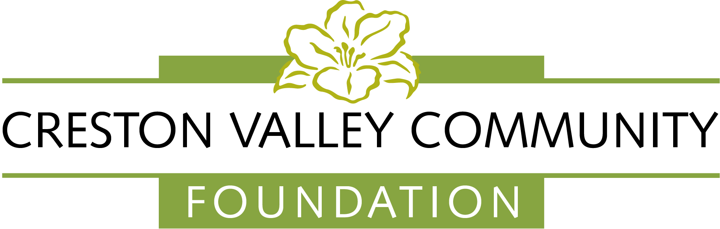
Grant Application Form

Please note that this version of the form has been created in a format that is best printed and filled out in handwriting.

- Applicant Information

Name of Organization: ____________________________________

Canada Revenue Agency Registered Charity # _________________
(If applicant is not a registered charity, then they must complete a Partnering Charity Agreement
form, located on our website)

Qualified Donee (partnering Charity if applicable): ______________________

Address: _______________________________________________

Contact Person: _________________________________________

Initiator or Author of Application: __________________________

Title: __________________________________________________

Phone: _______________

Email: ____________________

- The Project

Briefly (3-5 sentences maximum) describe your organization:

Is the project part of a larger initiative? If so, please provide an outline:

Describe your Project (3-5 sentences maximum):

What are the goals of the project?

Who will the project impact?

How will you measure the effect of the project?

When will the project begin and when will it be completed?

Start: __________________ Finish: __________________

How will the project be funded after start up is complete, if applicable?

Has the CVCF provided funds to your organization in the last 3 years? If so, please complete the following:

Year | Project | Size of Grant | Year Completed

How has the Foundation been recognized for these grants?



- The Budget

Please fill in the following tables and ensure that the total expenses equal the total revenues.

Expenses | Cost | In-kind | Total
In-kind volunteer hours
TOTAL

Revenues | Approved | Requested | Total
Amount requested from Creston Valley Community Foundation
Additional contributors either approved or requested (please list separately)
Amount contributed from your organization (cash or in kind)
Cash
In-kind
TOTAL

- Attachments

Please attach the following if you feel they are appropriate:

- Letters of Reference
- Needs Analysis
- Business Plan

If your organization is not registered with the Canada Revenue Agency, you must ensure that you have the support, involvement and a signed agreement with a registered charity prior to submitting this application.

- Waiver

Grant Applicants acknowledge and agree that:
Information provided on the Creston Valley Community Foundation’s grant application will be accessed by the Creston Valley Community Foundation Board of Directors and members of the Creston Valley Community Foundation granting committee. Photos, text and videos of grant recipients, project participants and grant funded projects, might be used by the Creston Valley Community Foundation for promotional and reporting purposes.

_______________________________
Signature

_______________________________ ______________________
Print name Board Position

________________________________
Date

Deadline for receipt of applications is February 28.

Please forward your application to: Creston Valley Community Foundation,
Box 701, Creston, BC V0B 1G0

Or by email to: grants@crestonvalleycf.ca

